Stripe implementation using Angular and Node.

1) Create an account on stripe.

2) Login the stripe account.

3) Follows these steps to get the secret api key and Public api Key.
- click on developes link that shows on right side of menu then click on api keys.

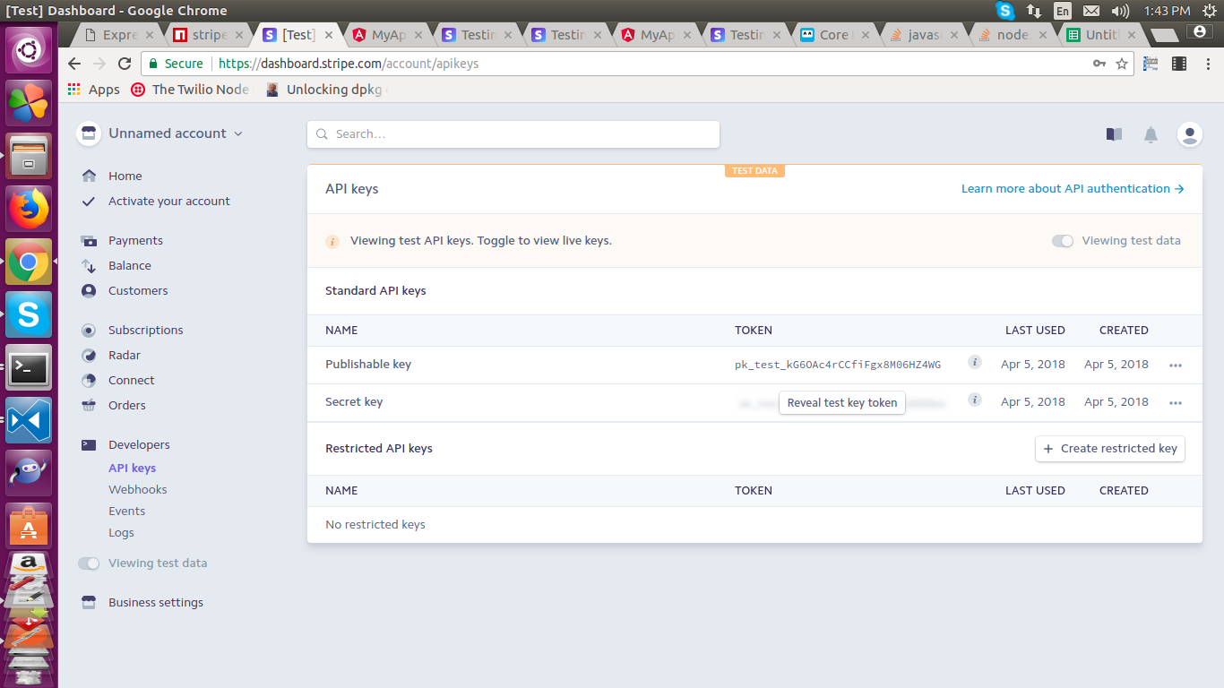

Angular Setup:

Use angular cli to generate an angular app.

4) Render the stripe script on main index.html.
“<script src="https://checkout.stripe.com/checkout.js"></script>”

5) Create a button on app.component.html file and call “openCheckout()” function on click of that button.
<button [disabled]="isSubmitting" class="btn btn-lg btn-primary purchase-button" (click)="openCheckout()">Pay Now</button>

6) Create an opencheckout() function in app.component.ts. This functions open the stripe window and give an token when you enter the correct card details. Opencheckout function also validate the card details. We can hit StripeCheckout function into opencheckout() function by passing parameteres.
1) Publish key : We got from stripe account
2) amount : amount to pay (any)
3) Email : Email of user (any)
4) name : Name of app (any)
5) Description : Description of app (any

Token: Token is an object type that contains details of card and user.

openCheckout() {
this.isSubmitting = true;
// this.errors = new Errors(); // removing error message
var amount = 8000;
var handler = (<any>window).StripeCheckout.configure({
key: "pk_test_kG6OAc4rCCfiFgx8M06HZ4WG", // client account
locale: 'auto',
token: token => {
this.makePayment(token,amount);
this.token = token;
console.log(this.token);
}
});
handler.open({
name: 'Jive',
description: 'Pay to Jive',
amount: amount,
email: "abc@gmail.com",
closed: closed => {
if(!this.token)
{
console.log(this.token)
this.isSubmitting = false
}
}
});
}

7) MakePayment() is an another method that is called internally on success with token as param,got as response from stripe when opencheckout() function is called. This method calls “makeStripePayment” stripeservice method .

makePayment(token: any,amount:any)
{
this.stripeservice.makeStripePayment(token,amount)
.subscribe(
data => {
this.message = data._body;
this.isSubmitting = false;
setTimeout(() => {
this.message = '';
}, 5000)
},
err => {
this.isSubmitting = false;
this.message = "something went wrong Please try again later";
setTimeout(() => {
this.message = '';
}, 5000)
}
);
}
}

8) Stripe Service method to hit node api.This api accepts two params “token” and “amount”.

makeStripePayment(token,amount): Observable<any>
{
debugger;
return this.http
.post('http://localhost:3000/stripe',{token: token,amount:amount})
.map(data => {
console.log(data);
return data;
});
};

Node Setup:

use express-generator to generate node sample app.

8) Install the stripe package using npm “npm install stripe –save” on server side.
Refer : https://www.npmjs.com/package/stripe

9) Initialize stripe , Pass secret key when you import or initialize the stripe package . Get secret key from stripe account shown on above point 3.

var stripe = require('stripe')("secret Key");

10) Hit the stripe Charges api for make a payment to stripe. Just pass the parameters.
1) amount : amount received by token ;
2) currency : “usd”;
3) description : pass user email as a description for user record on stripe.
4) source : pass token_id that is recieved by token.
Here is the code

router.post('/stripe', function (req, res, next) {

stripe.charges.create({
amount: req.body.amount,
currency: "usd",
description: req.body.token.email,
source: req.body.token.id,
}, function(err, charge) {
if(err)
{

return res.status(401).json({ errors: {'stripe': ["error occured during payment"]}});
}
else
{
return res.json("successfully Paid"
);
}
});

Refer: https://stripe.com/blog/official-nodejs-support

10) Check credits on click of payment link that appear right menu.

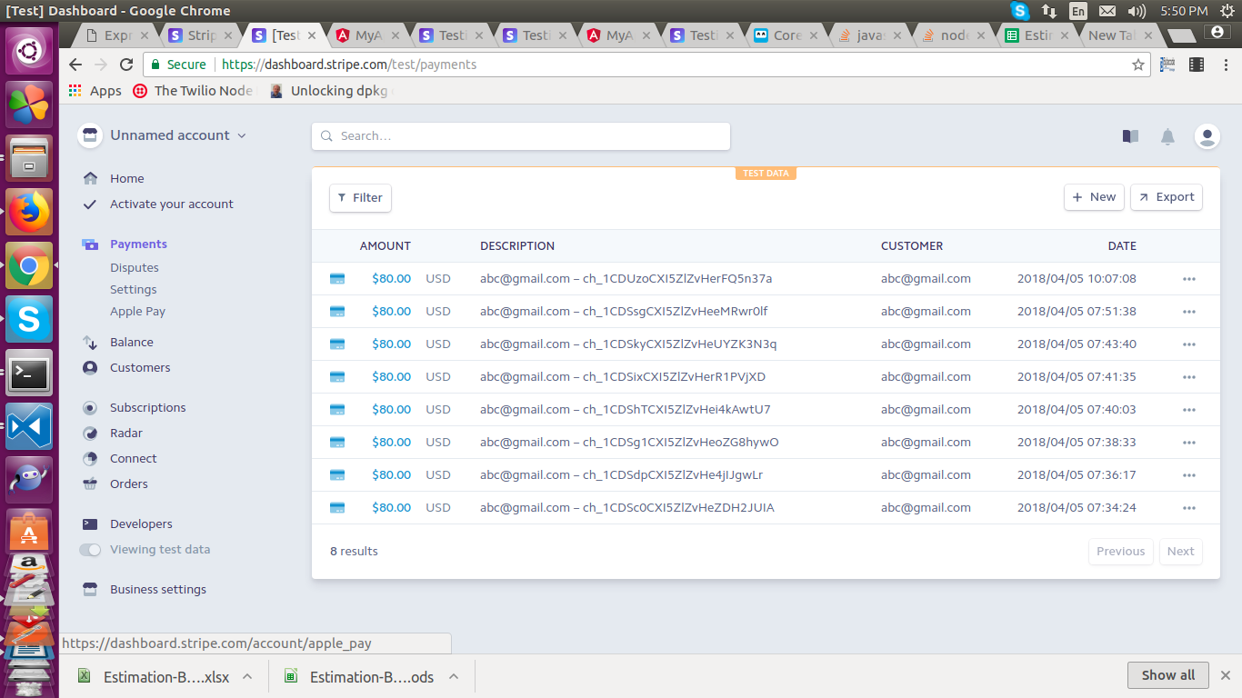

11). Stripe Documentation Link : https://stripe.com/docs/api/node#authentication

